November Kids Cooking Class

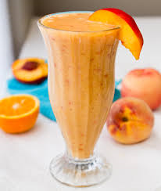
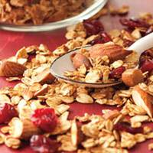
Saturday, November 21st
11:00 a.m.-12:00 p.m.
Conference Room
$10 per child, ages 5-12

Come join us and make some deliciously healthy holiday snacks!

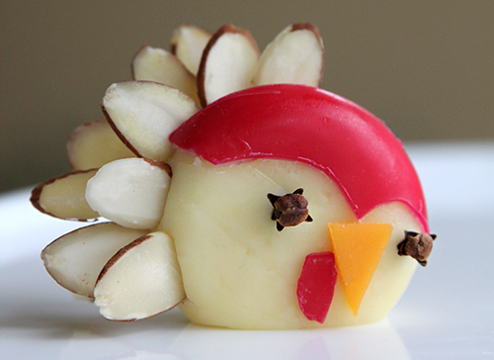
Turkey Roll-Up Snacks
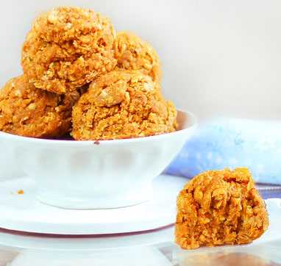
Cranberry Granola
No Bake Pumpkin Cookies
Orange Peach Smoothie

Led by Boone Hy-Vee Dietitian, Jocelyn Pohl, RD, LD, and Iowa State University dietetic student, Kaitlyn. Your child will have fun creating these fall-themed recipes and learn hands-on cooking skills.

Pre-Register at Customer Service or call 515-432-6065. Please register 24 hours in advance

